Fantasy Manager Database



Team IX

Requirements Specification and Database Design

Andrew Harrison

Sudhir Ray

# Table of Contents

Table of Contents v 1

1.0 Introduction 2

1.1 Purpose 2

1.2 Overview 2

2.0 Scope 2

3.0 Requirements 3

3.1 Business Rules 3

3.2 Entity Relationships 4

4.0 Database Design 6

4.1 Conceptual Design 7

4.2 Logical Design 8

# 

# 1.0 Introduction

## 1.1 Purpose

The purpose of this document is to describe the scope and requirements for the Fantasy Soccer Manager Database. This database aims to help users track their fantasy soccer leagues more efficiently and effectively.

## 1.2 Overview

Our client is ESPN, specifically their fantasy sports platform. ESPN's fantasy platform ranks among the most popular applications for fantasy sports. Although they currently offer fantasy leagues for the NFL, NBA, MLB, and NHL, our focus will be on adding soccer to their portfolio.

The platform allows users to draft, track, and manage virtual teams based on real-world sports. ESPN mainly attracts casual sports fans who enjoy an enhanced experience while watching their favorite games. However, one doesn't need to be a sports fan to enjoy playing fantasy sports.

# 2.0 Scope

The client requires a database specifically designed for the Fantasy Soccer Manager application. Our team will develop a database featuring various functioning entities, such as players, teams, and managers. These entities will have specific interrelationships to facilitate an easy-to-use and functional database. Our goal is to create an immersive fantasy soccer experience while ensuring accurate and fair gameplay through real-world statistics.

# 3.0 Requirements

This section outlines the specific requirements and business functions essential for our Fantasy Soccer Manager Database. It will provide details on each entity and outline a few business functions for each.

## 3.1 Business Rules

In this section, the business rules for the Fantasy Manager Database will be discussed. Each entity must have a corresponding ID that will be the primary key.

* A User/Manager must be registered with an email and password.
* A User/Manager can only be associated with one League.
* A User/Manager can only have one Team in a League.
* A Team must belong to a User/Manager.
* A Team must consist of at least 11 players and no more than 15.
* A Team must consist of at least 2 goalkeepers, 3 defenders, 3 mid-fielders, and 3 forwards. The final 4 players may be any position the User/Manger sees fit.
* A Players Market Value must be determined by Real-World statistics about the Player.
* A Player must belong to a Real-World Team.
* A Player can only be apart of one Team in the League.
* The Transfer Market must update player availability based on the fantasy transfers.
* A User/Manager can claim, trade, or drop players only through the Transfer Market.
* A Transfer Market will close as soon as the first game starts and will re-open 24 hours after the final game.
* A Match must involve exactly 2 Teams, no more no less.
* A Match must be calculated through points generated by Real-World Players statistics.
* A Match’s results must be determined no later than one hour after the last game has finalized.
* A Real-World Team must have a roster of Real-World Players.
* Real-World Players may be traded, dropped, or picked up by Real-World Team’s, which must be reflected in the Transfer Market.

## 3.2 Entity Relationships

* A League must have one or many Users/Managers.
* A User/Manager must be associated with one and only one League.
* A User/Manager must be associated with one and only one Team.
* A Team must be owned by one and only one User/Manager.
* A Team must have one or many Matches.
* A Match must have two and only two Teams playing against each other.
* A Team must have many Players.
* A Player may be associated with one and only one Team.
* A Player must belong to one Real-World Team.
* A Real-World Team must have many Players.
* A Player may be associated with multiple Transfers.
* A Transfer Market must be associated with exactly one Player.
* A User/Manager may be associated with multiple Transfers.
* A Transfer Market must be associated with exactly one User/Manager.

# 4.0 Database Design

The following two sections present the conceptual and logical designs for the Fantasy Manager Database. Our team's database comprises seven entities: League, Player, Team, User/Manager, Transfer Market, Match, and Real World Team.

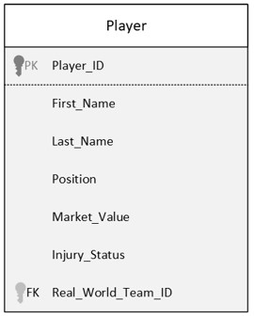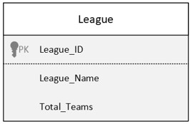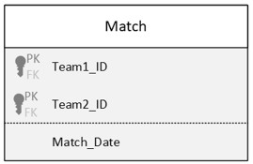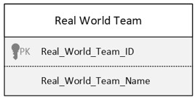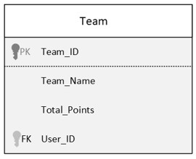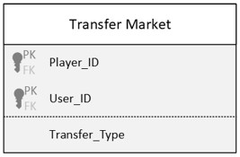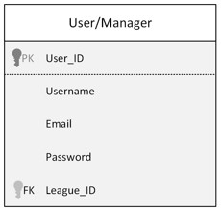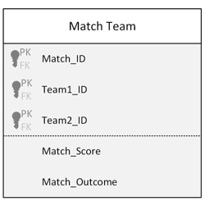

## 4.1 Conceptual Design

Figure 1.0 Details the conceptual design of our teams Fantasy Manager Database. This diagram shows the different entities associated with our team’s database as well as the relationships between each entity. Section 3.2 goes in detail about the relationships between each entity.

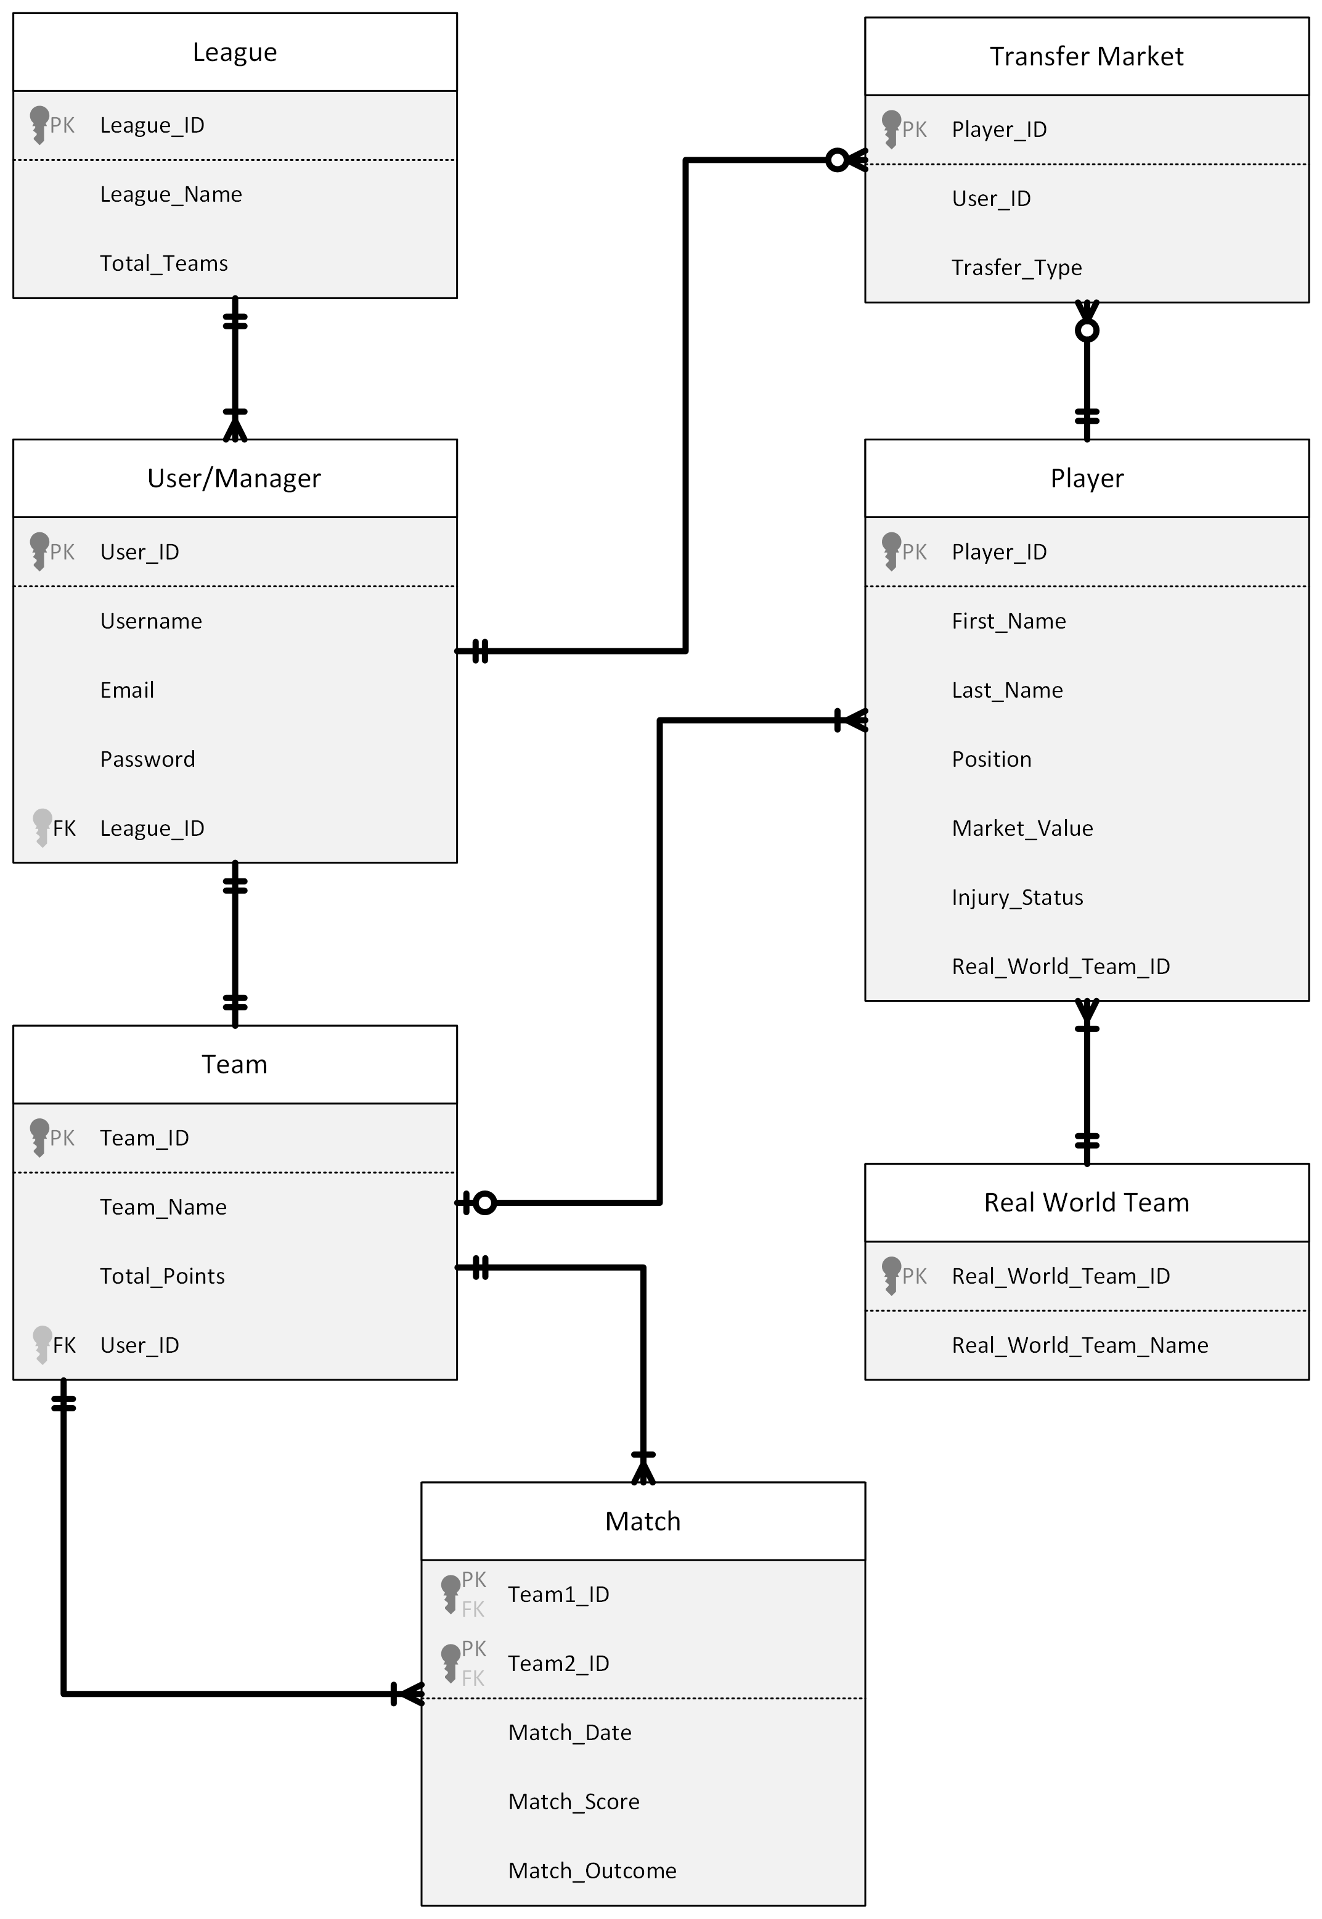Figure 1.0 Entity – Relationship Diagram

## 4.2 Logical Design

Figure 2.0 Details the logical design of our teams Fantasy Manager Database. This diagram translates the conceptual design or ER model into relations. This model shows the relation definitions as well as primary, foreign, and composite keys.

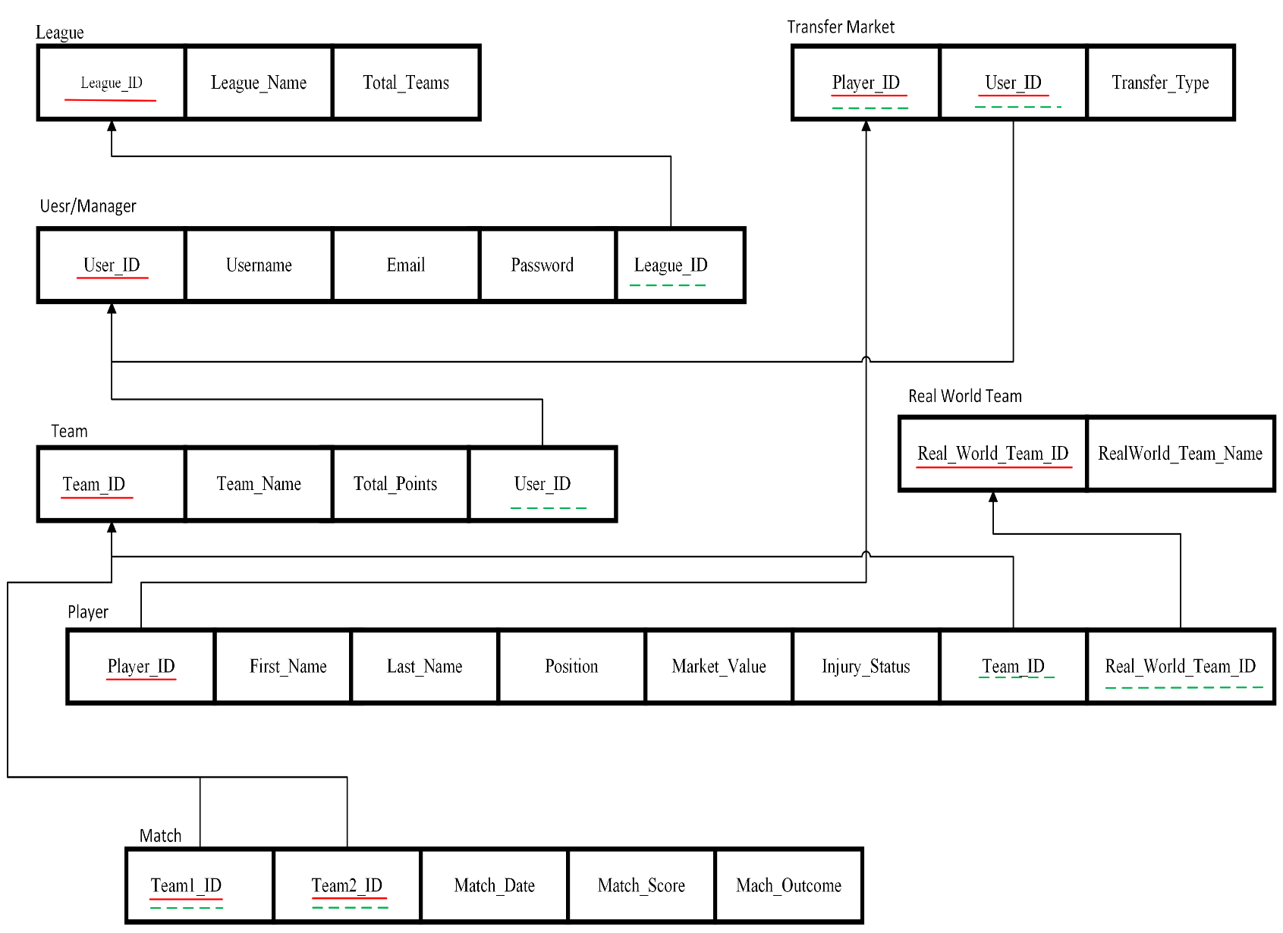Figure 2.0 Relational Model